SQL MURDER MYSTRY

Mystery: A crime has taken place and the detective needs your help. The detective gave you the crime scene report, but you somehow lost it. You vaguely remember that the crime was a murder that occurred sometime on Jan.15, 2018and that it took place in SQL City. Start by retrieving the corresponding crime scene report from the police department’s database.

QUERIES:

1.SELECT name

FROM sqlite_master

where type = 'table'

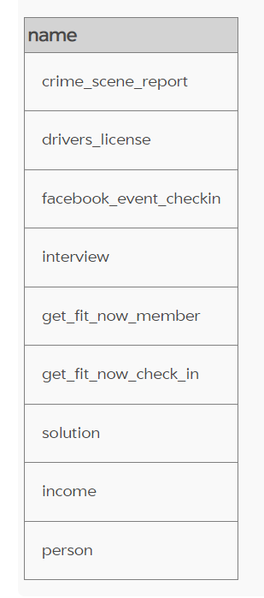

2. SELECT sql

FROM sqlite_master

where name = 'crime_scene_report'

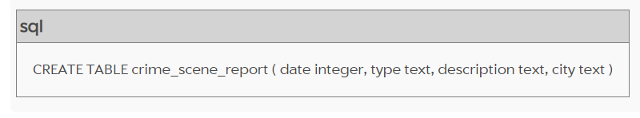

3. SELECT * FROM crime_scene_report where city= 'SQL City' and type= 'murder'

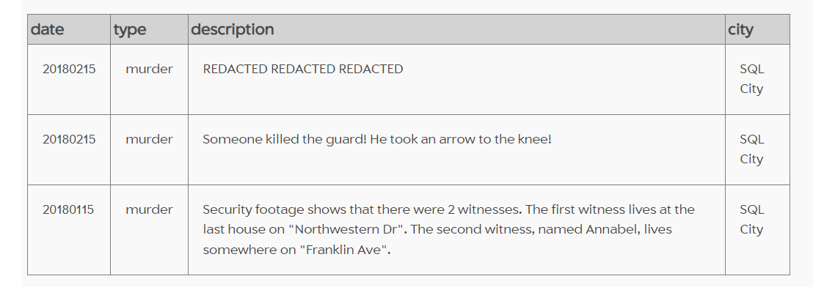

4. SELECT * FROM person where address_street_name LIKE "Franklin Ave"

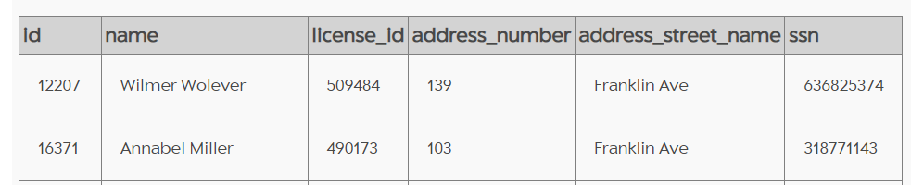

5. SELECT * FROM person where address_street_name LIKE "Northwestern Dr"

Order by address_number DESC

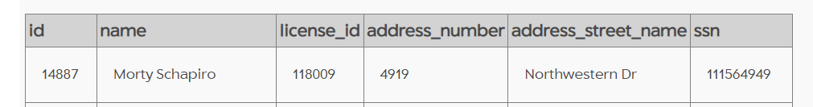

6. SELECT * FROM interview

where person_id=16371

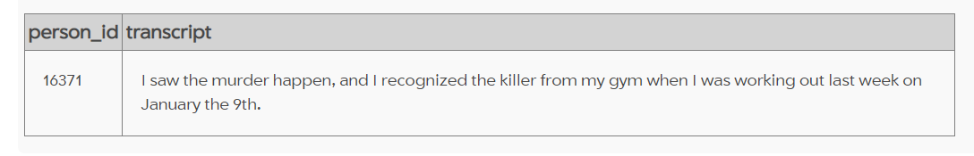

7. SELECT * FROM interview

where person_id=14887

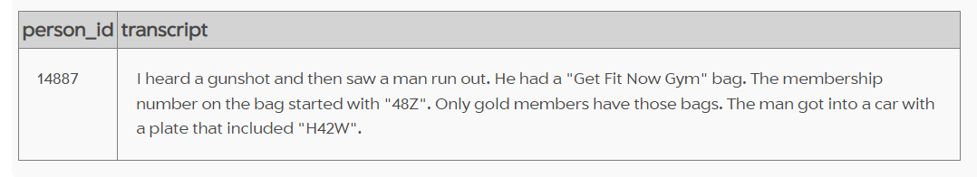

8. SELECT *

FROM get_fit_now_check_in

JOIN get_fit_now_member

ON get_fit_now_check_in.membership_id = get_fit_now_member.id

WHERE membership_id

LIKE "48Z%"

AND check_in_date=20180109

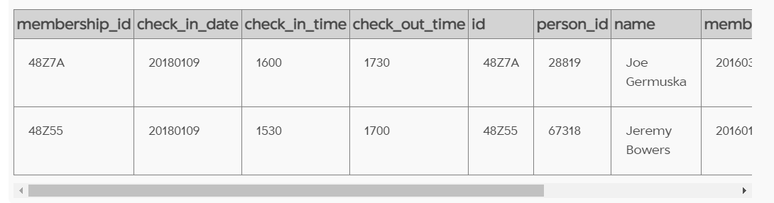

9. INSERT INTO solution VALUES (1, 'Jeremy Bowers');

SELECT value FROM solution;

